Problem 1 (20 points):
You are investigating a new enzyme that takes a simple substrate, S, and converts it into a much desire product, P. You realize that this transpires through the simple enzymatic reaction:
You are tasked with discovering the kinetics of this enzyme.
- You note in studying the enzyme that the forward reaction rate, k_{f} is 10 times faster than the reverse reaction rate, k_{r}, i.e., k_{f} = 10k_{r}.
- You start with and initial concentration of the substrate, S = s₀ and you measure the amount of product, P, produced in the first minute as the initial velocity of the reaction as V₀ (mMoles/min)
- You use 10 mMoles of enzyme (e₀=10 mMoles)
- The table below gives you the following results of your experiments:
Initial Substrate, S₀  Moles | Initial Velocity, V₀  mMoles/min
1 | 1.25
3 | 2.5
9 | 3.75
12 | 4.0

Let the initial concentration of C, c₀ = 0, and the initial concentration of P, p₀ =0
Find the only correct statement below and explain or demonstrate why.
- k₁ ≈ 1.724/min
- V_{max} = 5 mM/min
- K_{m} = 5.0 mM
- k₂ = 5/min
Using excel, a 1/S vs 1/V plot is made in order to obtain a linear equation via linear regression.

The terms of m and b within the formula are defined as followed: $m=\frac{k_{m}}{v}$ and
$b=\frac{1}{v_{max}}$. Through these terms, the values of $v_{max}$ and $k_{m}$ can be determined.
$$v_{max}=\frac{1}{b}=\frac{1}{0.2}=5\frac{mMol}{min}$$
$$k_{m}=m⋅v_{max}=0.6⋅5=3\frac{1}{min}$$
Using the definition of $k_{2}$ in terms of the present enzymes and $v_{max}$ it can be defined.
$$k_{2}=\frac{e_{o}}{v_{max}}=\frac{10 mMol}{5\frac{mMol}{min}}=0.5 \frac{1}{min}$$
Determine $k_{r}$ via the Michelous-Menton constant:
$$k_{m}=\frac{k_{r}+k_{2}}{k_{f}}, where k_{f}=10k_{r}$$
$$k_{m}=\frac{k_{r}+k_{2}}{10k_{r}}$$
$$10k_{m}k_{r}-k_{r}=k_{2}$$
$$k_{r}\left(10k_{m}-1\right)=k_{2}$$
$$k_{r}=\frac{k_{2}}{10k_{m}-1}$$
Insert the values of $k_{2}$ and $k_{m}$ to find $k_{r}$:
$$k_{r}=\frac{k_{2}}{10k_{m}-1}=\frac{0.5 \frac{1}{min}}{10\left(3 \frac{1}{min}\right)-1}=0.01724 \frac{1}{min}$$
Determine $k_{f}$ via its given definition in terms of $k_{r}$:
$$k_{f}=10\left(k_{r}\right)=10\left(0.01724\frac{1}{min}\right)=0.1724\frac{1}{min}$$
- Develop the dynamical formulas for this reaction (3 differential equations that explicitly and exactly describe the reaction)

$$\frac{ⅆS}{ⅆt}=-0.1724\frac{1}{min}∙S\left(e_{0}-C\right)+0.01724\frac{1}{min}∙C$$
$$\frac{ⅆC}{ⅆt}=0.1724\frac{1}{min}∙S\left(e_{0}-C\right)-\left(0.01724\frac{1}{min}+0.5\frac{1}{min}\right)C$$
$$\frac{ⅆP}{ⅆt}=C∙0.01724\frac{1}{min}$$

- Simulate the full enzyme reaction in Simulink.
- Make 2 plots: 1- complex formation phase in one simulation done over a short time horizon (1 min) and
- followed by the full product formation simulation done over a longer time horizon(30 min).
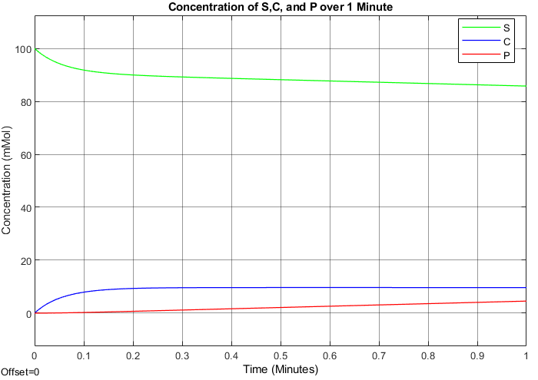
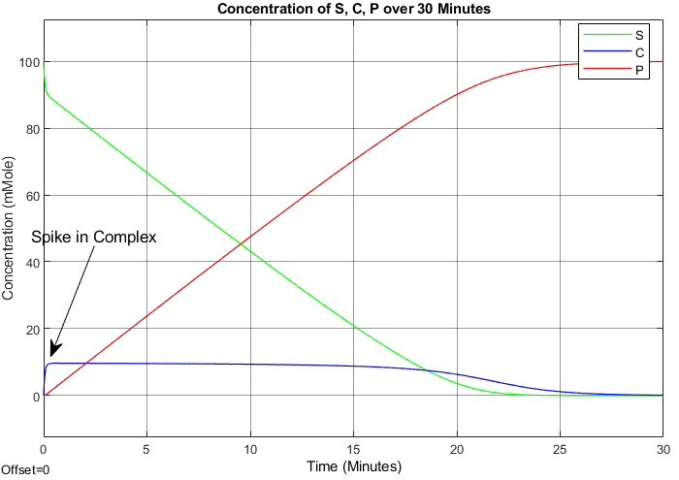
- Finally, develop the Michaelis - Menten equation for this reaction.
  - Plot Michaelis Menten equation result against the full dynamical equations on the same plots made in part a.
  - What are differences between the graphs in each plot. That is, explain what and why the two plots do not coincide.
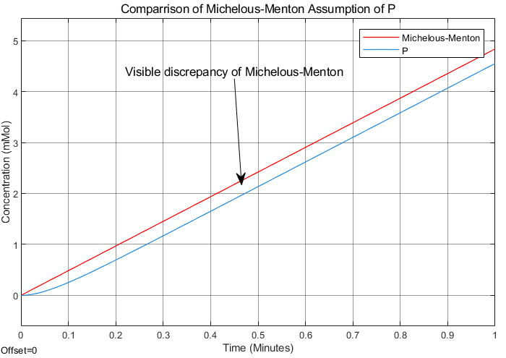
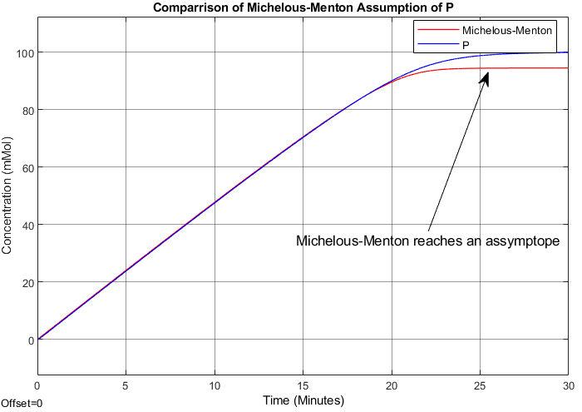
Problem 2 (20 points):

You are investigating a new enzyme through Michaelis Menten kinetics, and you have found that it has a maximum velocity of 6.0 $μ$M/s when the [E]₀ is 1.5 x 10⁻⁹ M based on the following data:

Initial velocity (V₀) | [S]₀
1.0 $μ$M/s | 20 mM
2.0 $μ$M/s | 50 mM
3.0 $μ$M/s | 100 mM
4.0 $μ$M/s | 200 mM
5.0 $μ$M/s | 500 mM

- Determine K_{m} of this enzymatic reaction (Hint: before going to do a lot of calculations, stop to THINK how this might be determined! – if it doesn’t come to you, go ahead and do a lot of calculations. I suggest MS Excel for the calculations though Matlab works)
- Plot the full Michaelis-Menten reaction using either Matlab or Simulink. Caution: This is not a plot of the data! The data gives you V₀ for each S₀. You have V_{max} as given. You found K_{M}. What you want is product as a function of time. Be careful of the units. The reaction is slow and you will need a longer runtime

Problem 3 (20 points): (Multiple Choice Questions requiring Explanations)
Which statements about enzyme catalyzed reactions are NOT true? Explain your answer and explain why the statements that are not true are false Enzymes form complexes with their substrates
  - Enzymes lower the energy of activation for chemical reactions.
True. An enzyme function is powered by the lowering of the activation energy needed for reactions to proceed, thus increasing the reaction rate.
  - Enzymes change the equilibrium constant (K_{eq} or K_{ss}) for chemical reactions
False. Enzyme doesn’t change the equilibrium constant of a reaction. They only increase the rate at which equilibrium is reached through lowering the energy required for activation.
  - Many enzymes undergo conformational changes when binding with substrate

  - For enzymatic reactions to occur at the “active site” of enzymatic proteins, the 3D orientation of substrate molecules is an important feature of the reaction
  - Enzyme inhibition can always be overcome by adding more substrate
Problem 4 (20 points)
Consider the following set of data and answer the following questions:
[S] Moles | V (umol/min) | V (+inhibitor) umol/min
6.00E-06 | 20.8 | 12
1.00E-05 | 29 | 15
2.00E-05 | 45 | 20
6.00E-05 | 67.6 | 24
1.80E-04 | 87 | 27
3.00E-04 | 92 | 27

- Plot the data (the velocities are the initial velocities) on a Lineweaver-Burk plot (be sure to label axes)

- Determine the Vmax & Km of the reaction without the inhibitor

$$y=2×{10}^{-7}+0.0106$$
$$v_{max}=\frac{1}{0.0106}=94.34\frac{μmol}{mol}$$
$$k_{m}=M⋅v_{max}=1.89×{10}^{-5}\frac{1}{min}$$

- The second set of velocities represents the rate of the reaction when the inhibitor is added. Plot these data on the same graph as above.

- Do the two trendlines seem parallel?

Yes, visually they seem to be nearly perfectly parallel.

- Looking at their slopes by what factor are they not parallel.

Though the two trendlines seem to be parallel, their equations say otherwise with a slope of 3e-7 present in the inhibitor sample and a slope of 2e-7 present in the sample without the inhibitor.

- Given that this is actual experimental data, do you think the difference is significant?

No, though there can be a multitude of reasons as to why the slope in the inhibitor sample. There could have been a contaminant present in the sample without the inhibitor causing it to have a reduced $k_{m}$ value or vice versa for the inhibitor sample.

- State the type of inhibition is present (competitive, non-competitive,
uncompetitive).
Uncompetitive, explain
- Can the effects of the inhibitor be over-ridden by adding more substrate? If so, explain why?

PROBLEM 5 (20 points)

PhosphoFructokinase-1 (PFK-1) is an essential enzyme in glycolysis. It converts fructose-6-phosphate (F-6-P) to fructose -1,6 – biphosphate (F-1,6-BP) You have a lab experiment with this enzyme, and you derive the following experimental data (13 initial substrate concentrations and 13 velocity measurements):

F-6-P Concentration  S(0) | Velocity of production of F-1,6-BP
0.1 | 0.1
0.5 | 1.1
1 | 3
2 | 9
3 | 15
5 | 22
7 | 26
10 | 28
13 | 29
16 | 29.5
18 | 30
20 | 30
24 | 30

- Plot the experimental data.
- Does this data and plot suggest Michaelis-Menten dynamics or Hill dynamics.
- If your answer was Michaelis-Menten dynamics, derive the K_{m} and V_{max} but if your answer were Hill dynamics, derive the Hill coefficient, the Hill K, and V_{max}

